**MS BOOKINGS SYSTEM FOR ADULT SAFEGUARIDNG MEETINGS**

**HOW TO BOOK GUIDE FOR SOCIAL WORKERS**

**Overview**

* Team Managers and Social Workers must use the [Safeguarding Adults Minute-Taker Booking (office365.com)](https://outlook.office365.com/owa/calendar/SafeguardingAdultsMinuteTakerBooking@LBCamden.onmicrosoft.com/bookings/) system to book their meetings. This system is also linked to the CSF calendar, which is managed by Safeguarding and Statutory Minute Taker team. This allows them to view the bookings and ensure that a Minute Taker is allocated.
* The link to access this booking system is <https://outlook.office365.com/owa/calendar/SafeguardingAdultsMinuteTakerBooking@LBCamden.onmicrosoft.com/bookings/> (please copy this link into your browser to access the booking system)
* PLEASE NOTE, IF THERE IS NO AVAILABILITY FOR THE DATE AND TIME YOU REQUIRE, PLEASE EMAIL [safiye.dervis@camden.gov.uk](mailto:safiye.dervis@camden.gov.uk) and [tina.bird@camden.gov.uk](mailto:tina.bird@camden.gov.uk) WHO WILL CHECK MINUTE TAKER AVAILIBILITY – **PLEASE DO NOT SEND A DIRECT CALENDER INVITE TO TINA BIRD’S CALENDER AS YOUR BOOKING COULD BE MISSED WHICH COULD RESULT IN YOU NOT GETTING A MINUTE TAKER FOR YOUR MEETING.**
* PLEASE NOTE, **ALL** ADULTS SAFEGUARDING MEETINGS MUST BE BOOKED THROUGH THE MS BOOKINGS SYSTEM.

**Using the MS Bookings System to book your meeting**

1. Please copy the link the into your internet browser

<https://outlook.office365.com/owa/calendar/SafeguardingAdultsMinuteTakerBooking@LBCamden.onmicrosoft.com/bookings/>

1. The booking page will look like this.

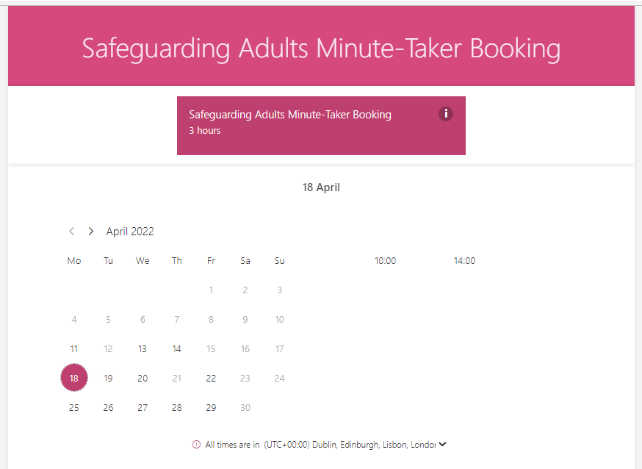

* The adults booking system only has two bookings slots available each day - **10am and 2pm.**
* Once you select the date, you can select the time slot. If you’re meeting is before 2pm, please be advised to book the 10am slot and change the time in the booking selections and apply the same rule for any meetings you are booking after 2pm. Click on 2pm and state the time in the selections.
* **N.B.** The adults booking systems calendar does not identify the actual time the SW has put in the selections, so bookings are booked into the calendar as either a 10am start or 2pm start, however, when you click onto the booking it will show the actual start time that the SW has stated. This is the time that the minute taker will be given to attend.
* **N.B.** If there are no time slots indicated on the date you have selected, this means that both the slots for that day have been booked and you will be unable to book a slot.
* Once you have selected your date and time slot, you will see a series of drop-down selections. You must ensure that you complete all the fields.

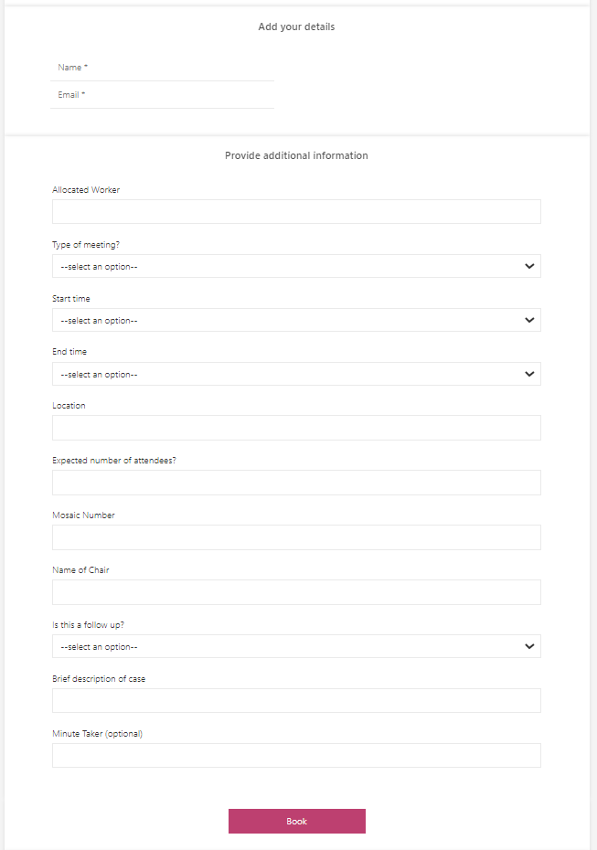

1. Once you have entered all the fields, click on ‘Book’ and your meeting will be booked and Safeguarding and Statutory Minute Taker team will be notified of your booking. You will also receive confirmation of your booking.

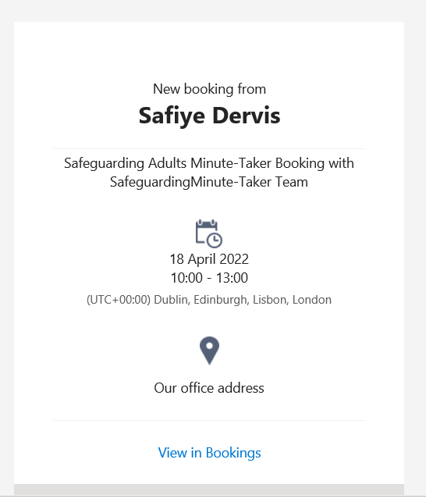

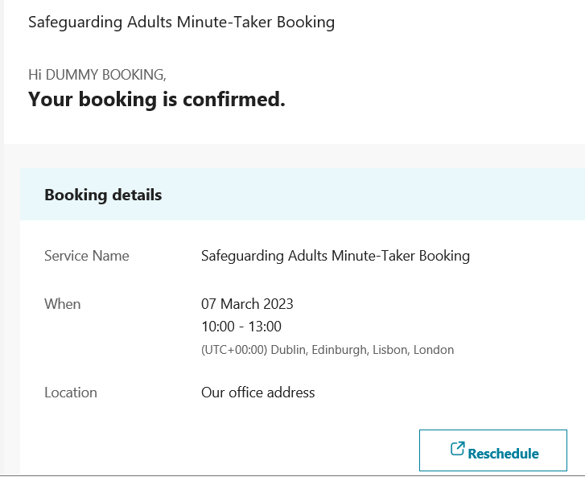

1. If you no longer require your booking, please ensure that you cancel your booking on the booking system via your confirmation email.

**PLEASE NOTE, IF YOU HAVE ANY QUERIES, PLEASE CONTACT** [**SAFIYE.DERVIS@CAMDEN.GOV.UK**](mailto:SAFIYE.DERVIS@CAMDEN.GOV.UK) **AND TINA.BIRD@CAMDEN.GOV.UK**