# Part 1: Accessing the Skills and Qualifications Area in Oracle Applications

[Type here] [Type here] [Type here]

1. 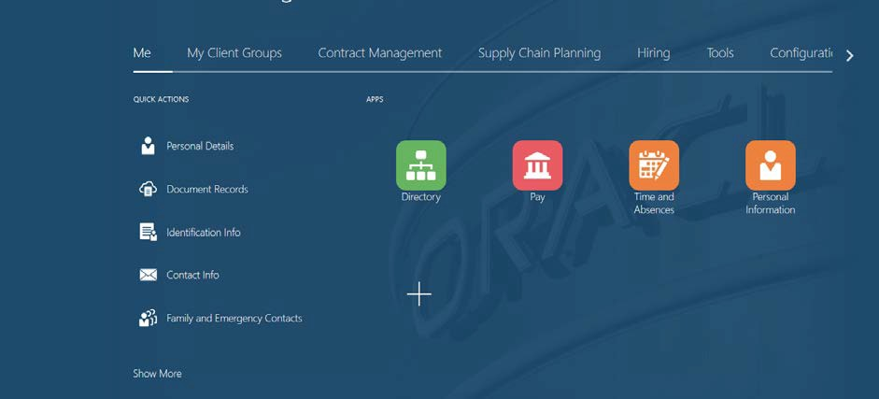Open Oracle Applications. The screen should resemble that shown below but the number of tabs/options available will vary depending on an employees’ role within the organisation.
2. Ensure that ‘Me’ is selected and click on ‘Show More’

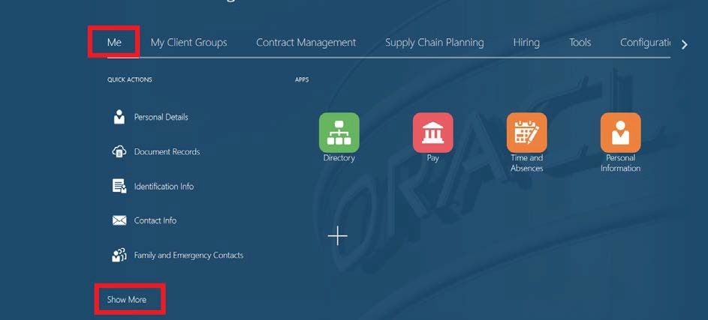

1. The amount of options available will increase. From the list of options, click on ‘My Public Info’

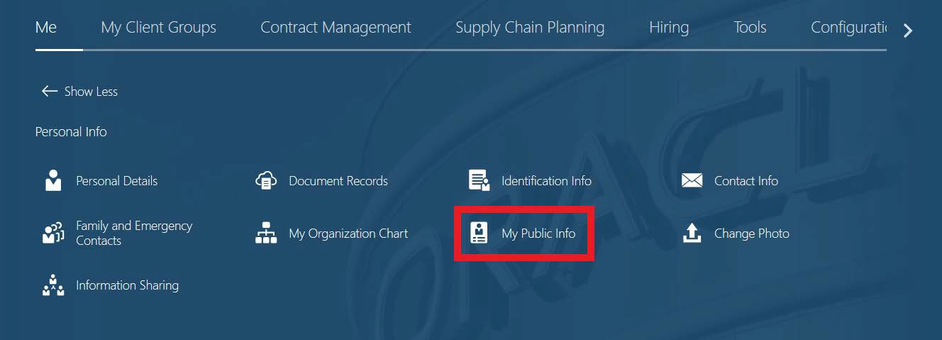

1. The Public Info Screen will then appear. From the left-hand side menu, click on ‘Show More’

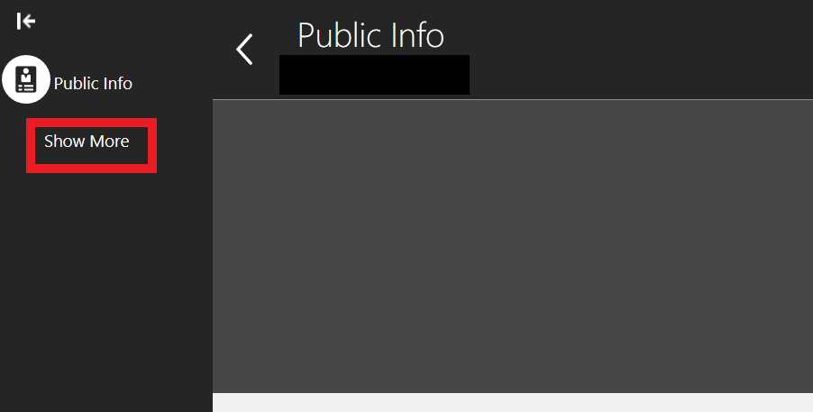

1. Again, the amount of options available will increase. Click on ‘Skills and Qualifications’

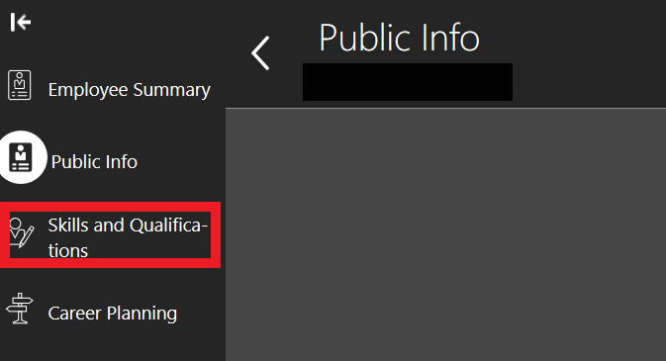

1. You can then amend/add the qualifications and memberships on the system on the system by selecting ‘Edit’ and then following the steps outlined in adding *Professional Memberships*

# Part 2: Supplementary Information – Editing and Deleting Professional Memberships

**Editing Records**

1. To adjust an existing professional membership record expiry date, please select the ‘Pencil’ instead of clicking the ‘+’ button next to Professional Memberships, this will then enable you to edit the end date.



1. Make the relevant changes in the editing screen and then click ‘Submit’

# Deleting Records

1. If a record requires deleting, this can also be done by selecting the ‘Pencil’ option next to degrees



1. Click on the ‘X’ button the right-hand side of the qualification to be deleted

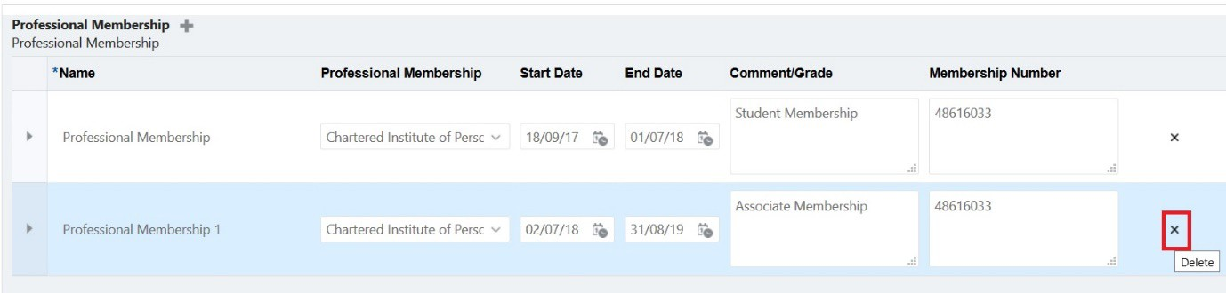

1. The record will then be removed from the list. Once all records requiring deletion have been removed click on ‘Submit’

# Part 3: Adding Professional Memberships

The level of information will depend on whether or not any professional memberships have already been added:

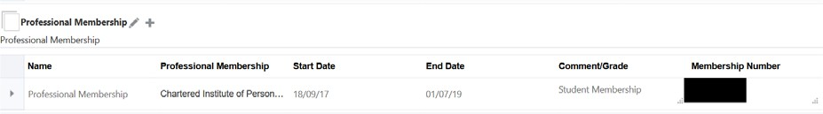

1. To add a new professional membership to the system, click on ‘+’ button next to Professional Membership

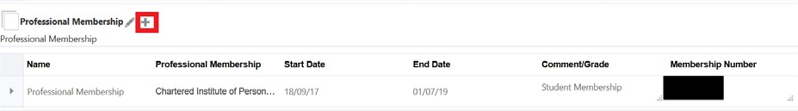

1. The editing screen will then appear on screen as show below. Click on the drop-down box visible under the ‘Name’ field

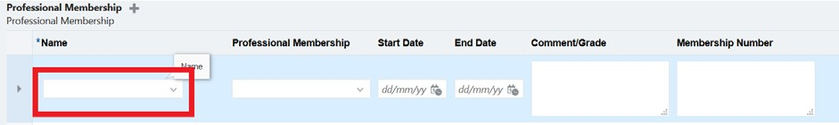

1. Select the relevant Professional Membership record number you wish to give it and then click on the drop-down box under the ‘Professional Membership’ field. If no records are present already, select ‘Professional Membership’. For all subsequent records added, selected ‘Professional Membership 1’, ‘Professional Membership 2’ etc. for each new record added.
2. Next, click on the drop-down menu listed under ‘Professional Membership’

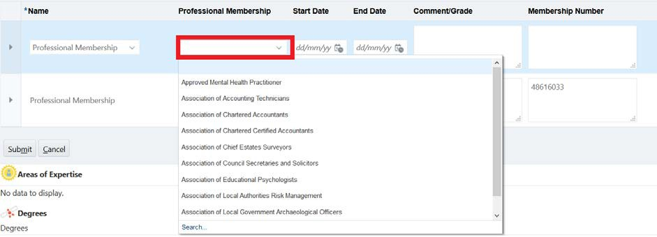

1. The list will initially going return the first set of professional membership available to be viewed, click on search and then the full list will be available to view.

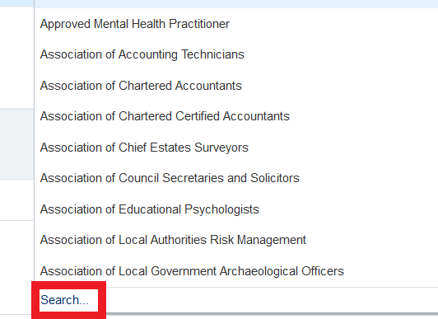

1. Once the relevant professional membership has been located, click on it so it’s highlighted and then click on ‘Submit’

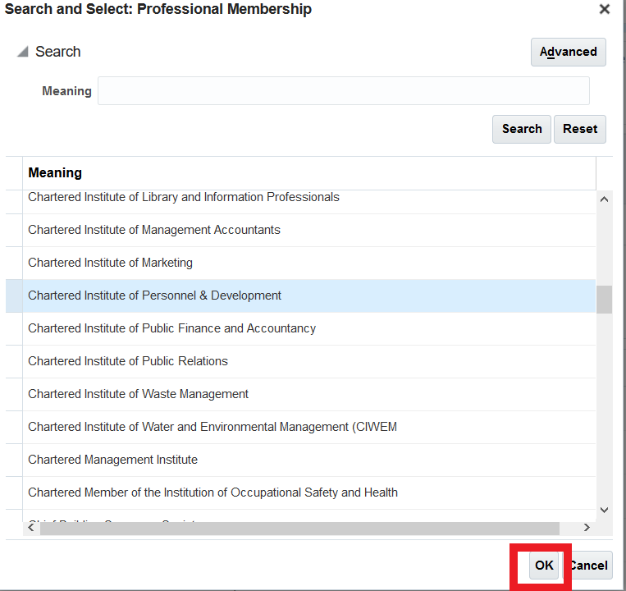

1. In the ‘Start Date’ and ‘End Date’ fields, use the calendars to select the date the Professional Membership commenced and what date is due to expire.

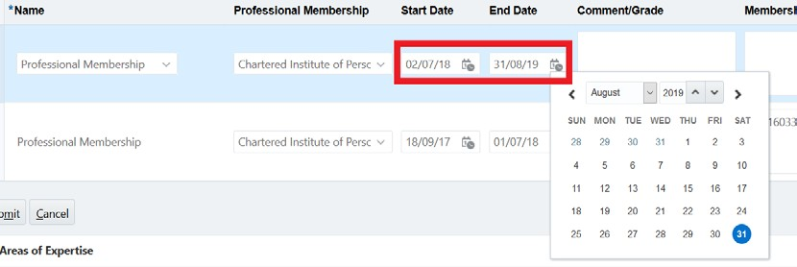

1. Once the type of qualifications and dates have been entered, enter the following information into the free type cells under the ‘Comment/Grade’ and ‘Membership Number’ fields:
   1. Comment/Grade: Any information relevant to the qualification e.g. level
   2. Membership Number: The membership number the provided to the employee by the organisation

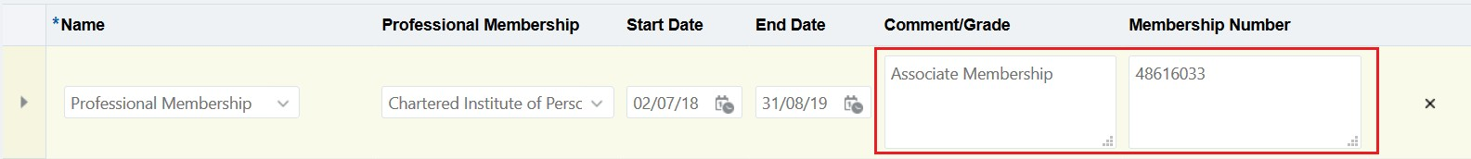

1. Repeat steps 2-8 as required if more professional memberships need to be added. Once all relevant details have been added. Click on the ‘Submit’ at the bottom of the Qualifications box.

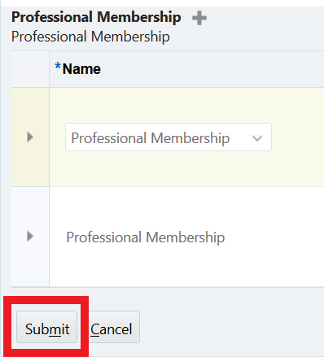

# Part 3: Supplementary Information – Editing and Deleting Professional Memberships

**Editing Records**

1. If at a later date, amendments need to be made to an existing professional membership record e.g. qualification has been completed and result known this can be through the same steps but instead of clicking the ‘+’ button next to Professional Memberships click on the ‘Pencil’



1. Make the relevant changes in the editing screen and then click ‘Submit’

# Deleting Records

1. If a record requires deleting, this can also be done by selecting the ‘Pencil’ option next to degrees



1. Click on the ‘X’ button the right-hand side of the qualification to be deleted



1. The record will then be removed from the list. Once all records requiring deletion have been removed click on ‘Submit’