**Stay Interviews**

Stay interviews are all about finding out what’s working well for staff and what they might want to change about their experience of working here. Stay interviews can help with retaining staff by exploring what’s keeping them working here, what could improve their working lives even more, and what might be leading them to think about leaving. Its also a great opportunity as part of regular contracting and re-contracting between supervisor and supervisee and getting feedback about what they’re finding helpful and valuable. Finally, it’s a deeply respectful practices that demonstrates care for the worker and a curiosity about what motivates them and sustains them.

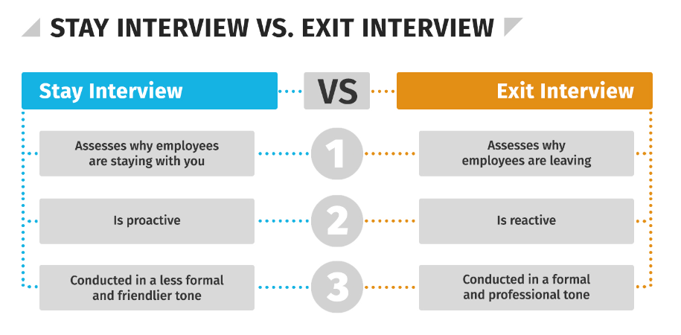

**Some examples of stay interview questions**

* What kind of feedback or recognition would you like that you’re not currently receiving?
* What opportunities to develop professionally would you like to have and is Camden supporting you with those?
* What kinds of flexibility would be more helpful to you in balancing your work and home life (think about using the Camden Wellbeing Passport here if needed)
* What talents, interests or skills do you wish you could use more in your role or that we haven’t made full use of yet?
* What have you felt good about, or particularly proud of, in your job and in your time here?
* If you could change one thing about your job, what would it be?
* What do you look forward to the most when you come to work each day? What do you look forward to the least?
* What would you miss most if you left this job for another role?
* Do you feel you have the tools and resources you need to do your job? If not, whats missing?
* Do you feel like you are connected to your teammates? If no, what would help to improve that?
* What could I do to support you better?