**This is my world**



**Name _____________________________**

**This is me**

What words best describe you?

* _________________________
* _________________________
* _________________________
* _________________________
* _________________________
* _________________________

Please draw a picture of yourself

My name is _______________________________________________

I am ___________ years old

The colour of my eyes are ____________________________________

My hair colour is ___________________________________________

My mum’s name is __________________________________________

My dad’s name is ___________________________________________

When I grow up I want to be __________________________________

I am really good at _________________________________________

I am thankful for __________________________________________

The people who support me are ___________________________________________

[](http://www.google.com/url?sa=i&rct=j&q=&esrc=s&source=images&cd=&cad=rja&uact=8&ved=2ahUKEwj19KrrrtzgAhUCD2MBHVszA_UQjRx6BAgBEAU&url=http://clipart-library.com/alien-cliparts.html&psig=AOvVaw3odCzj1y_J9FSZX8cSbud5&ust=1551372434642199)

If I was an alien how would you tell me about you and your family?

__________________________________________________________________________________________________________________________________________________________________________________________________________________________________________________________________________________________________________________________________________________________________________________________________________________________________________________________________________________________________________________

**My favourite …**

Colour: ______________________________________________________

Game: ______________________________________________________

Animal: _____________________________________________________

Sport: ______________________________________________________

Food: _______________________________________________________

Person: _____________________________________________________

Film: _______________________________________________________

**When I am happy I think …**

[](http://www.google.com/url?sa=i&rct=j&q=&esrc=s&source=images&cd=&cad=rja&uact=8&ved=2ahUKEwj8gdOqsdzgAhVH1eAKHYp-AOoQjRx6BAgBEAU&url=http://clipart-library.com/happy-cliparts.html&psig=AOvVaw09QxNNsLQb6QWLV_fIklbH&ust=1551373104139701)

**When I am sad I think …**

[](http://www.google.com/url?sa=i&rct=j&q=&esrc=s&source=images&cd=&cad=rja&uact=8&ved=2ahUKEwjzzLCTstzgAhVwD2MBHU8nCfMQjRx6BAgBEAU&url=/url?sa%3Di%26rct%3Dj%26q%3D%26esrc%3Ds%26source%3Dimages%26cd%3D%26ved%3D%26url%3Dhttps://pngimage.net/miserable-png/%26psig%3DAOvVaw2ye6CcwhA7k5uSXWpqid1q%26ust%3D1551373323851368&psig=AOvVaw2ye6CcwhA7k5uSXWpqid1q&ust=1551373323851368)

**When I am angry I think …**

[](https://www.google.com/url?sa=i&rct=j&q=&esrc=s&source=images&cd=&cad=rja&uact=8&ved=2ahUKEwiksauwstzgAhUPNBQKHc8fBuEQjRx6BAgBEAU&url=https://mrmen.fandom.com/wiki/Mr._Rude&psig=AOvVaw2ZjNSg7PJj_Ll428JxtLIS&ust=1551373385104509)

**My feelings**

One thing that makes me happy ___________________________________

I can tell I’m happy when ________________________________________

I laugh when _________________________________________________

One thing that makes me sad is ___________________________________

I can tell I’m sad when __________________________________________

I cry when __________________________________________________

One thing that makes me angry is __________________________________

I can tell I’m angry when ______________________________________________________

What words best describe you, add each word to a branch

Anxious

Brave

Calm

Confident

Excited

Hopeful

Hurt

Lonely

Overwhelmed

Scared

Silly

Tired

Worried

Disappointed

Angry

Beautiful

Cheerful

Embarrassed

Frustrated

Happy

Hopeless

Jealous

Loving

Proud

Sad

Shy

Smart

Unsure

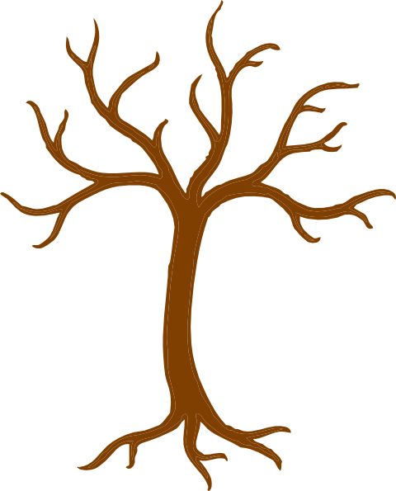

Draw a picture of your family



**My three wishes ...**

[](http://www.google.com/url?sa=i&rct=j&q=&esrc=s&source=images&cd=&cad=rja&uact=8&ved=2ahUKEwj44JCW7t7gAhVD2OAKHTtrBy8QjRx6BAgBEAU&url=http%3A%2F%2Fclipart-library.com%2Fstar-clip-art.html&psig=AOvVaw0n8N1o_NbkNIUezIjaZOPo&ust=1551458143152911)

________________________________________________________________

________________________________________________________________

________________________________________________________________

If you could put anything in the bin what would it be?

[](http://www.google.com/url?sa=i&rct=j&q=&esrc=s&source=images&cd=&ved=2ahUKEwi8mrre7t7gAhV06uAKHZwKDScQjRx6BAgBEAU&url=http%3A%2F%2Fworldartsme.com%2Ftrash-container-clipart.html&psig=AOvVaw0CbGpSDYrlX-GkNUzJSH04&ust=1551458306722756)

What would you put in your worry bag?



?

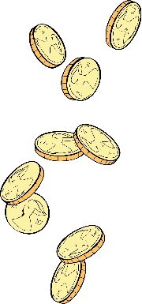If you could toss a coin into this fountain what would you wish for?

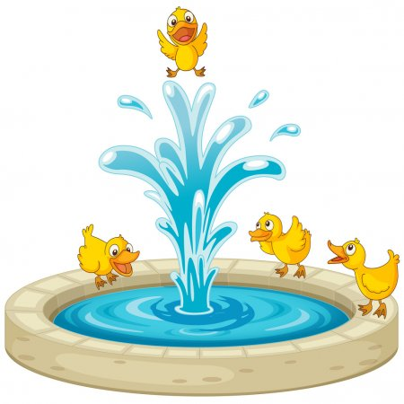

Drawing paper

Drawing paper