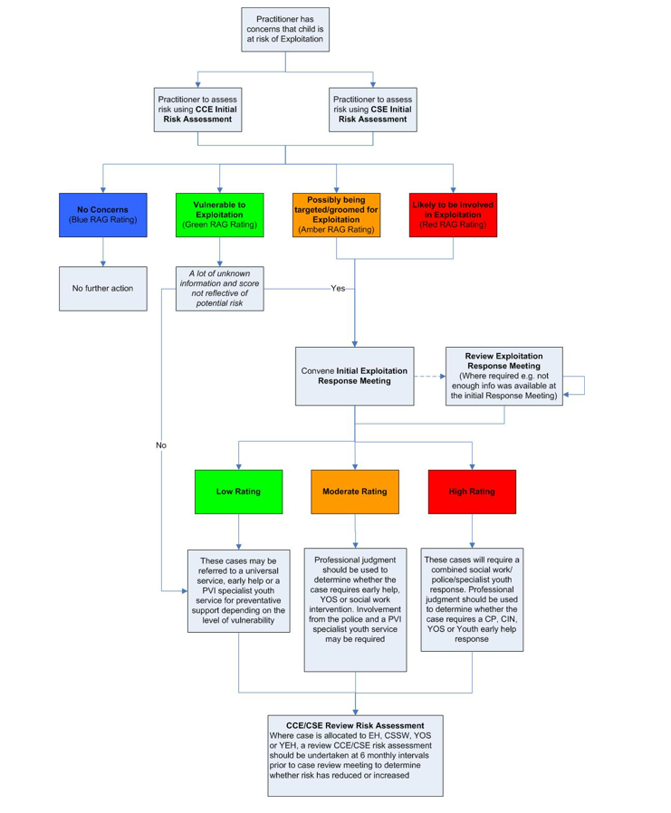

**Child Exploitation Flowchart**