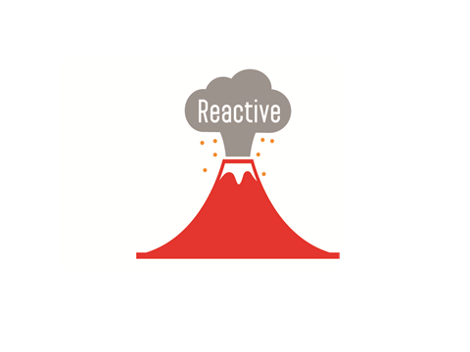

**Get active with Reactive**

Reactive Forum is an activity based forum

for disabled young people aged 13 to18

C:\Rich\images & symbols\logos\Camden logo black.jpgC:\Rich\images & symbols\image store\Speak_Up_Bubble_small.tif

Dates of our next 3 meetings

**Friday 10th December**

**Friday 14th January**

**Friday 11th February**

There’s lots going on at Reactive Forum, you can

* meet new people
* gain new skills for your future
* use computers, play pool and table tennis
* meet decision makers and guest speakers

Young people talk about things that affect you as residents living in Camden and how best to tell the Council your views. The Council asks Reactive about things like getting a job, having a place to live and services for young people and their families.

Reactive Forum meets at Somers Town Youth Centre once a month on a Friday during school term times

from **11am** 🡺 **2pm**



**2021**



If you want to get involved, your school support worker can contact Catherine Andrews Senior Disability Youth Worker on 07827859417

**Catherine.andrews@camden.gov.uk**