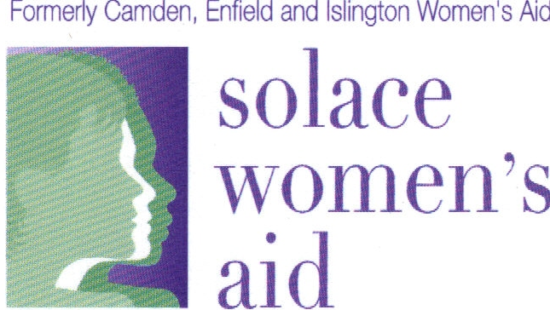

Solace Women’s Aid – Camden Holistic Therapeutic Support Service Referral Form for External Agencies

(Please email this completed form to Camden.HTSS@solacewomensaid.org or Camden.holistic.tss@solacewomensaid.cjsm.net )

Please ensure if making this referral for a child that the child’s details are entered wherever ‘service user’ is referred to. If wishing to refer for more than one child from the same family please add each child’s details separated by a ‘/’ on each relevant section.
Date of referral:
Has the service user/parent if referring a child provided consent for a referral to the Camden Holistic Therapeutic Support Service and for her/his details to be shared?

All sections must be completed

Section A
WHICH SERVICE DOES SERVICE USER WISH TO ACCESS? Please tick all that apply
One to One Counselling for adult women + men:

Group Work for adult women:
Four different types of Group are provided including Life Skills

Children’s Therapy (for children who are not living with the abusing parent):

Women’s Support Group around experience of Domestic Violence (Women’s Voices):

Support Group for mothers/female carers:

Section B
SERVICE USER DETAILS
Full name:

DOB:
Non abusive parent/carers full name (if referring a child):
Address:

Is it safe to send letters?

Home No: |  | Is it safe to call?
Home No: |  | Safe to leave messages?
Mobile No: |  | Is it safe to call?
Mobile No: |  | Safe to leave messages (text and voicemail)?
Email Address: |  | Is it safe to email?
Preferred form of contact:

Section C
REFERRER DETAILS
Referral Agency :
Referrer Name:
Title:
Telephone Number:
Email (secure if possible)
Date referral made:
Date referral acknowledged by service:
DASH RIC completed? Numerical Score and date:
Copy of DASH RIC supplied?
Has Service User been referred to MARAC?

Section D
CHILDREN (if referring a child please provide details of siblings here)
Does the service user have children/ siblings?

If yes, do the children/siblings live with the service user?

Children’s Names | DOB | Gender | Ethnicity
Are there any child protection concerns?
If yes please provide name and contact details of Social Worker if applicable

Section E
ALLEGED PERPETRATOR
Name | DOB | Gender | Ethnicity | Relationship to service user
Address (if different to service user)
Previously lived with service user?
Length of relationship with service user

Section F
ADDITIONAL INFORMATION (if completing this referral for a child please answer the questions in this section for both child and parent/carer eg. Does mum and or child require an interpreter.)
Relationship status and living situation (i.e. living with alleged perpetrator?)
Does the service user require an interpreter?
If yes, please specify which language.
Is the service user involved with Social Care?
If yes, please tell us how they currently support the service user.
Contact details of service users’ own Social Worker

Are any other agencies working with the service user at present?
If yes, please provide contact details

Is the service user involved in an ongoing criminal court case?

Does the service user have any physical health issues?
If yes, please provide details

Has the service user been diagnosed with any mental health issues?
If yes, please provide details

Does the service user use drugs and/or alcohol?
If yes, please provide details of the drugs/alcohol and how often these are used

Has the service user ever harmed herself/himself?
Please provide details

Has the service user ever attempted to take her/his own life?
If so please provide details

Section G
INFORMATION REGARDING THE VIOLENCE/ABUSE EXPERIENCED
Why are you referring the service user? Please describe the main issues relating to the domestic abuse i.e. frequency, when began, length of relationship:

DOMESTIC VIOLENCE
Type of abuse experienced (tick all that apply)
□ Physical
□ Emotional
□ Rape
□ Sexual offences
□ Financial
□ Childhood sexual abuse
□ FGM
□ Forced Marriage
□ Honour Based Violence
□ Trafficking (inc. all forms of exploitation)
□ Stalking
□ involved in prostitution +/or sex industry

Section H
Additional information on the service user
GP name, address and contact details:

Medication if applicable:

Any further information you would like us to be aware of i.e. pending court case, having other therapeutic support?

Once we receive the referral we aim to contact the service user and referrer within 48 hours

Section I
Monitoring information

Solace Women’s Aid is committed to providing equal opportunity and working towards a fairer society by avoiding unlawful discrimination in the provision of its services. In order to monitor the effectiveness of our Equality and Diversity Policy and to ensure equality of opportunity for service users, we would be grateful if you could answer the following questions.

How did you hear about our services?

Ethnicity of service user
Asian – Bangladeshi |  | Chinese |  |  |  |  |  | White – European
Asian – British |  | Mixed – White Asian |  |  |  |  |  | White – Other
Asian – Indian |  | Mixed – White & Black African |  |  |  |  |  | White – Gypsy/Traveller
Asian – Pakistani |  | Mixed – White & Black Caribbean |  |  |  |  |  | Mixed Ethnicity
Asian – Other |  | Latin American |  |  |  |  |  | Any other Ethnic Group
Black – African |  | Middle Eastern |  |  |  |  |  | Don’t Know
Black – British |  | Arab |  |  |  |  |  | Prefer not to say
Black – Caribbean |  | White – British
Black - Other |  | White - Irish
Nationality
African |  | Bangladeshi |  |  |  |  |  | British
Chinese |  | Korean |  |  |  |  |  | Polish
Irish |  | Turkish |  |  |  |  |  | Other
Immigration status
UK National |  | Indefinite Leave to Remain |  |  |  |  |  | Spousal visa
EEA-European |  | Other
Does the service user have recourse to public funds?
Disability
Blind or visually impaired |  | Mobility |  |  |  |  |  | Not disabled
Learning difficulty |  | Progressive/chronic illness |  |  |  |  |  | Prefer not to say
Mental health |  | Physical
Other disability |  | Other disability
Deaf
Deaf or hearing impaired |  |  |  |  | Prefer not to say
Not deaf
Gender/Identity
Female |  | Intersex |  |  |  |  |  | Prefer not to say
Male |  | Other
Transgender |  | Unknown
Sexual Orientation
Bisexual |  |  |  |  |  | Lesbian
Asexual |  |  |  |  |  | Other
Gay Man |  |  |  |  |  | Don’t know
Heterosexual |  |  |  |  |  | Prefer not to say
Religion/Belief
Agnostic |  | Humanist |  |  |  |  |  | Zoroastrian
Atheist |  | Jain |  |  |  |  |  | Jehovah Witness
Baha’i |  | Jewish |  |  |  |  |  | Shinto
Buddhist |  | Muslim |  |  |  |  |  | None
Christian |  | Rastafarian |  |  |  |  |  | Other
Hindu |  | Sikh |  |  |  |  |  | Prefer not to say
Age
Under 16 |  | 25-34 |  |  |  |  |  | 65+
16-17 |  | 35-44 |  |  |  |  |  | Prefer not to say
18-21 |  | 45-54
22-24 |  | 55-64
Pregnancy
Pregnant |  |  |  |  |  |  |  |  | Yes |  | No

