**Universal Credit Portal Guidance**

This note gives a step by step guide to each page on the Portal.

**Remember that accuracy is key** so please take time to complete the forms carefully as mistakes will delay the claim.

1. The first screen you will see is a **To do list**:

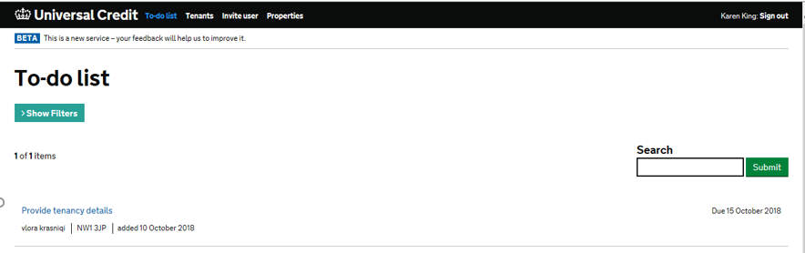

Click on your case. Note this screen will also show (on the right-hand side) the deadline by which the form should be submitted and if it is a NEW CLAIM.

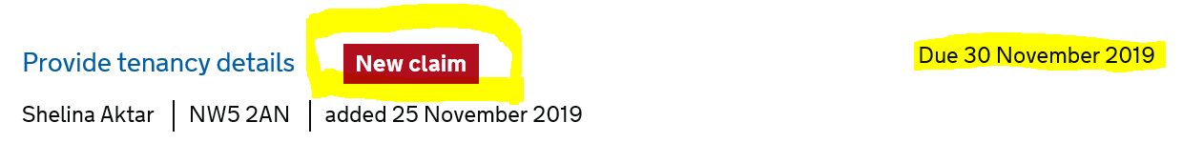

1. Select the case you wish to work on and it will take you to the **confirm tenancy details** page: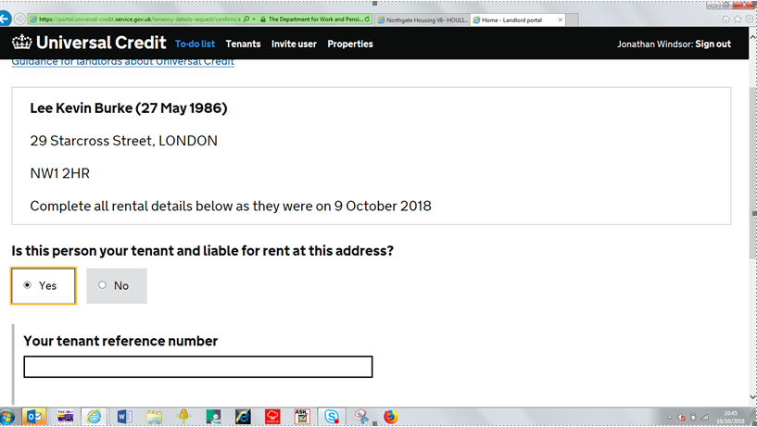

* You will usually check the ‘yes’ box
* Insert our pay reference number in the tenant reference number box,
* If the person is not your tenant, click no and an extra text box will appear so you can explain why.
* Please put a clear and concise explanation in that text box because it will be read by the case manager, who will then investigate.
* You will be asked if we will accept other charges (use and occupation).

1. **Tenancy Details** Screens

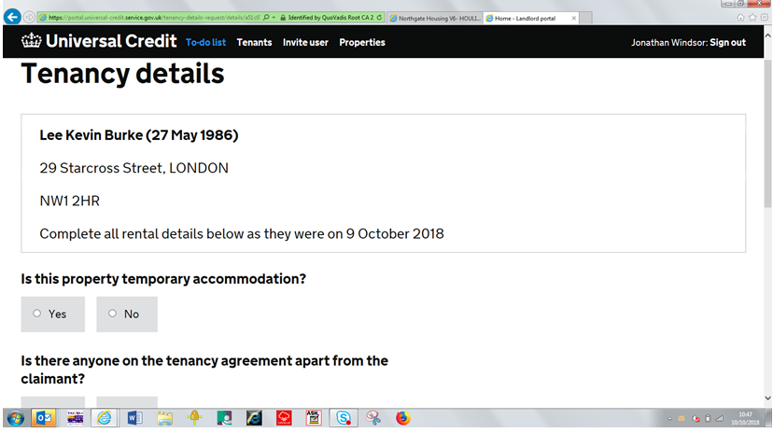

* Click ‘no’ to the temporary accommodation question.
* If it’s a joint tenancy, click yes and a text box will appear so you can enter details.

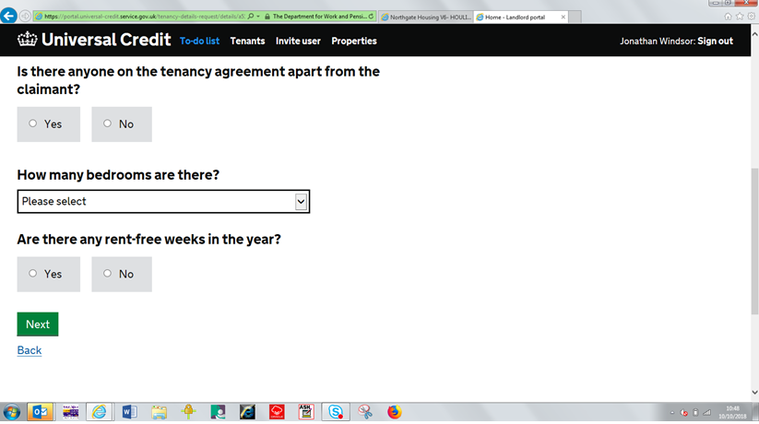

Check Northgate for the bedroom size and always say there are no rent free weeks.

1. The next screens ask about **Tenancy Costs.**

Use the **UCRL** to complete the eligible and ineligible charges.

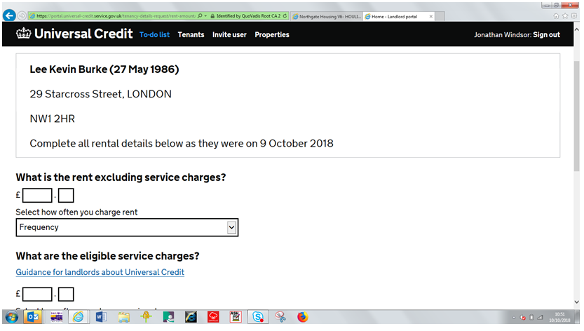

* Fill in these amounts carefully and double check you’ve not made any errors.
* Select weekly from the drop down frequency box.

1. The **Check and Confirm Details** screen gives you a final chance to check your information is correct before submitting.

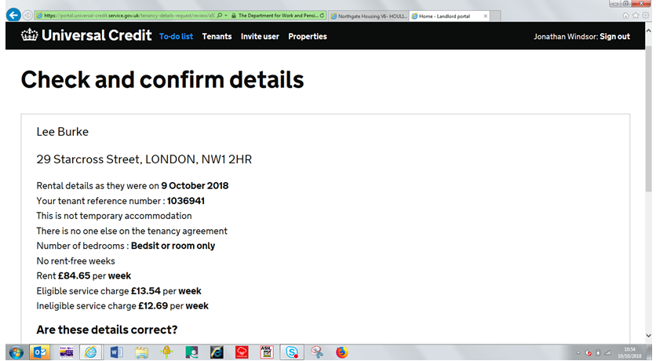

1. To apply for managed payments for the housing costs and/or 3rd party deductions, select the Tenants tab. Enter the tenant’s name in the Search box and press Submit.

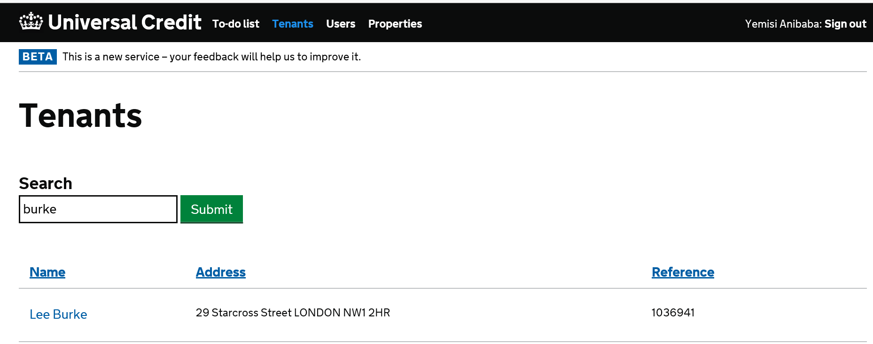

Click on the name. Click on ‘request alternative payment arrangement of rent arrears deduction’. Complete the details, ensure they are accurate, and submit.

