**2.12 The Community Genogram**

The community genogram is another useful tool for gathering culturally encompassing client data (Ivey and Ivey, 1999). Indeed, the goal for using such a genogram is to bring cultural issues to the forefront in the assessment process and to focus on the positive resources that come from understanding the multiple components of one’s cultural experiences. Ivey and Ivey (1999) explicitly recommend that when helping clients construct community genograms, therapists should focus on stories of strength, rather than on problems. Such a focus often leads to client recollections of useful strategies they had relied upon in the past that can be implemented to help solve current issues.

The process of constructing a community genogram entails two major steps (Ivey and Ivey, 1999). First, clients should be instructed to develop a visual representation of the community in which they were primarily raised and/or the community support network that they are currently residing within. Client representations of such communities will vary from concrete pictures to more abstract or symbolic representations (see Figure 2.3 for an example of a completed community genogram).

Once the community is drawn, the next step is to have clients draw themselves or a symbol of themselves within that community, followed by a representation of their family members’ places within that context. Then clients are instructed to place the most important or influential people or groups in their lives onto the community genogram and to connect the various individuals and groups to the client in such a way as to indicate which people are most influential (i.e., bold lines to represent stronger ties, dashed lines to represent more distant associations).

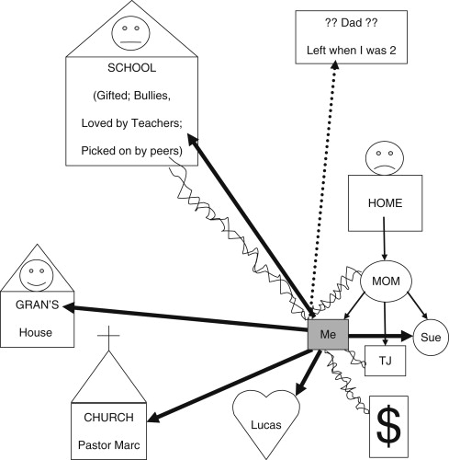

[Sign in to download full-size image](https://www.sciencedirect.com/user/login?returnURL=https%3A%2F%2Fwww.sciencedirect.com%2Ftopics%2Fmedicine-and-dentistry%2Fgenogram)

Figure 2.3. Example of a completed community genogram. Based on the development and discussion of this community genogram, the strengths and resources identified for this client included his high intelligence level and ability to excel in school, supportive relationships with his teachers, grandmother, sister, boyfriend, pastor and church community. Areas of weakness and destructive forces included his difficulties in relating to his peers, brother, and mother and his complete lack of information related to his estranged birth father. He identified that many of the conflictual relationships in his life centered around issues related to his sexuality and his family’s low socioeconomic status, which were issues out of his control. He also identified how resilient he had been and how optimistic he remained about his future.

The second major step in the use of genograms includes helping the client to find images and to tell narratives of strengths based on the community representation that he or she previously developed. To find these positive resources, clients should be instructed to choose one community group or the family to focus upon. Once a focus group is chosen, clients are asked to develop and fully experience visual, auditory, or kinesthetic images that represent something positive about their connection to that community group. This step is repeated with at least two more positive images from different community groups. Therapists then engage clients in a discussion of what they learned, thought, and felt via the process of this genogram construction and reflection on positive images.

The process of constructing a community genogram is often very powerful and emotion-laden for clients. For therapists, the process typically provides a window into the unique cultural background of clients. Finally, constructing a community genogram leads to a “reservoir of positive experiences that can be drawn on to help you and the client throughout counseling” (Ivey and Ivey, 1999, p. 240). Indeed, placing the community genogram on the wall at each therapy session will further ensure that clients and therapists call upon the cultural strengths identified and remember to always consider multiple perspectives on any issue (Ivey and Ivey, 1999).

From

[The Intersection of Positive Psychology and the Practice of Counseling and Psychotherapy](https://www.sciencedirect.com/science/article/pii/B9780123745170000024)

*Jeana L. Magyar-Moe PhD, in* [*Therapist's Guide to Positive Psychological Interventions*](https://www.sciencedirect.com/book/9780123745170)*, 2009*