**Healthier Ready Meals**

**Introduction**

At the moment we’re living under some pretty exceptional and challenging circumstances. Though home-cooking with fresh ingredients would always be the preference, in these exceptional circumstances it may be that microwave meals are the only option available to us.

This guide can help support you to choose healthier ready meal options. Have a look below for some quick steps to help understand the information on the back of food packets and check out our 5 top tips on page 2!

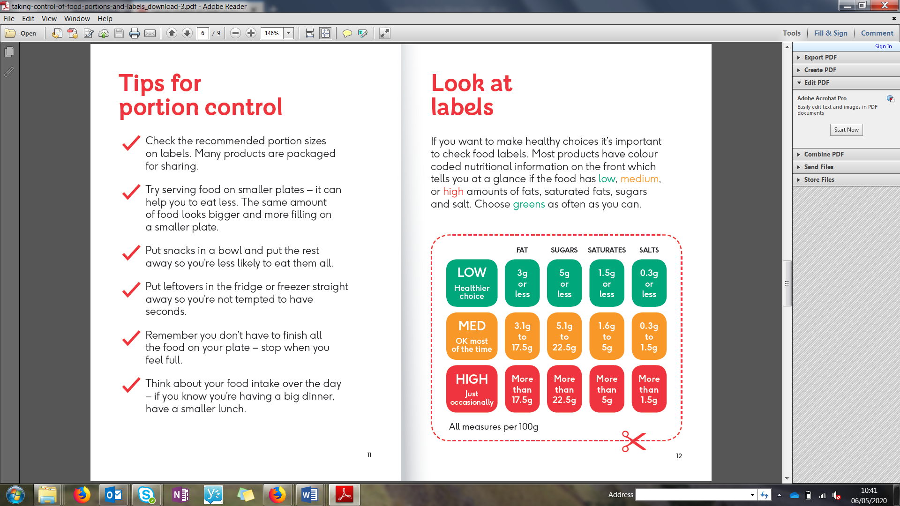**Understanding the label**

Learning to read food labels is a helpful way of making healthier choices.

On this pack below, the front of pack traffic lights show that saturated fat and sugar are green (low).

However, fat and salt are orange. To find out more, use the label reading steps below and table to the side to read nutrition information for fat and salt on the back….

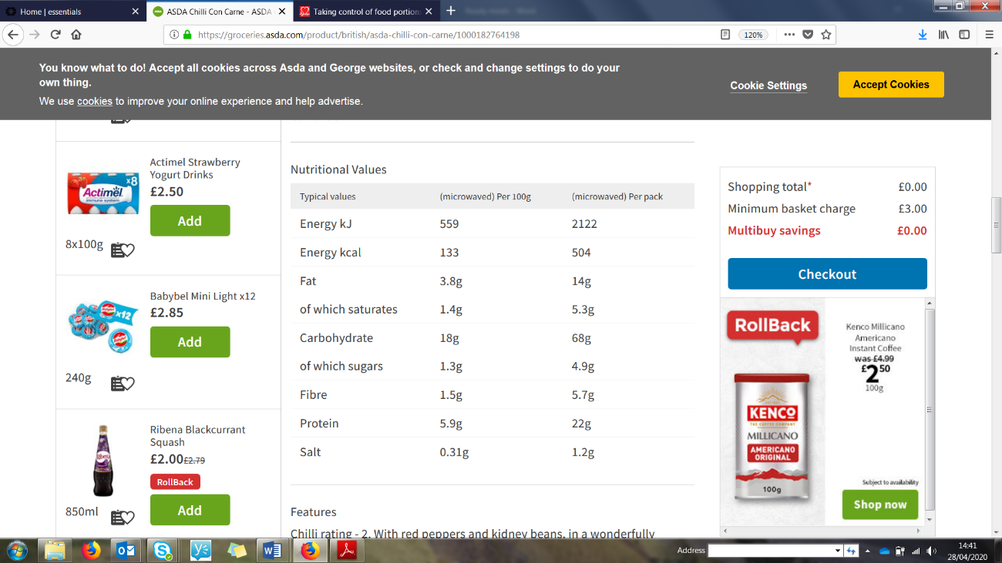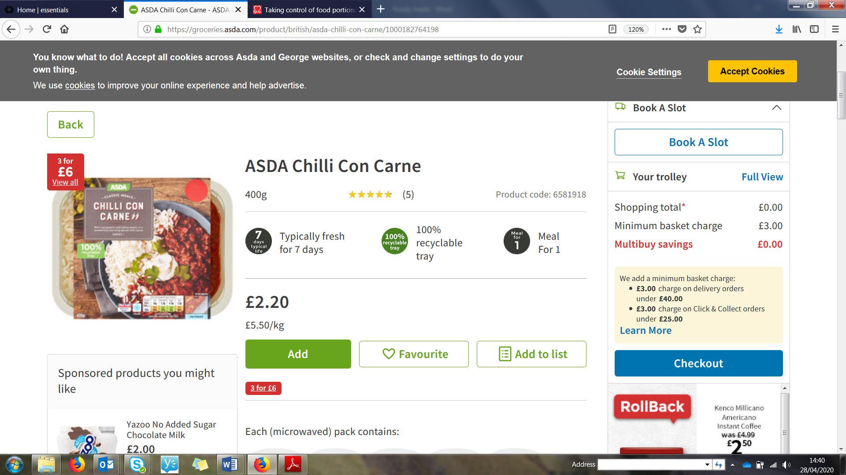

Nutrition information

Step 1: Check the ‘**per 100g’** column

* Ignore the ‘per pack’ or ‘per serving’ column

Step 2: Check the total **fat**.

* Medium is between 3g and 17.5g per 100g. This has 3.8g per 100g so is low-medium and therefore a good choice

Step 3: Check the **sugar**

* Low for sugar is below 5g per 100g. This has 1.3g per 100g so contains a low amount of sugar.

Step 4: look at the number for **salt**.

* Low salt is less than 0.3g and high is more than 1.5g per 100g. As this pack has **0.31g per 100g it is a medium salt choice**

Asda Chilli Con Carne

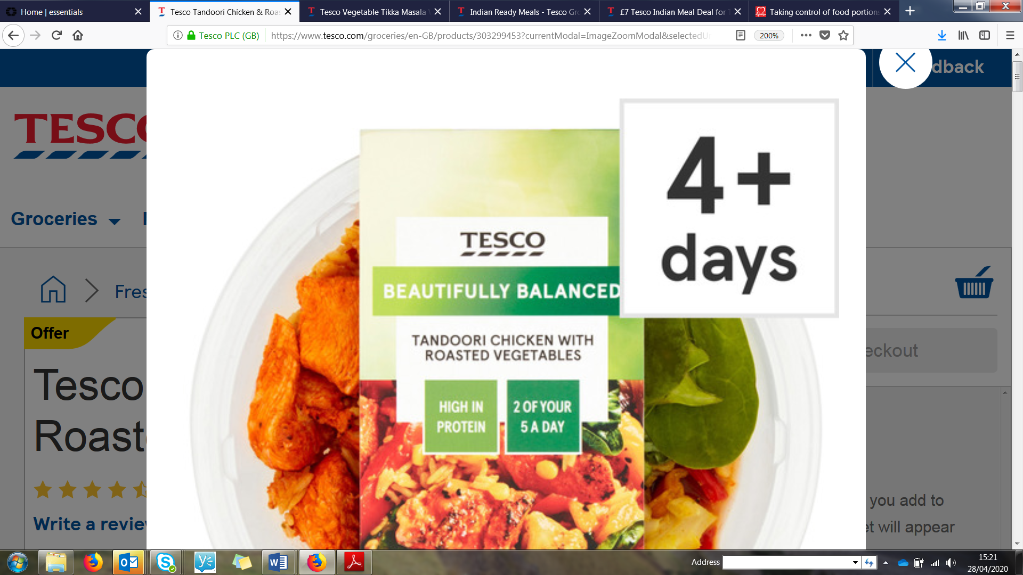**1 – Pick a meal with some vegetables or add your own!**

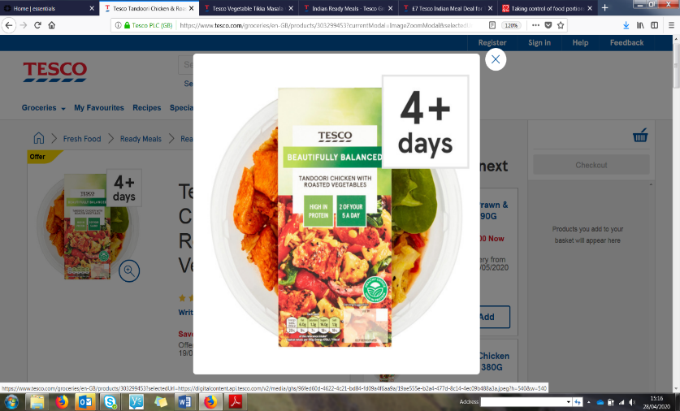

* Look for meals that have the 5 a day logo like this Tandoori Chicken with roasted vegetables from Tesco.
* If the ready meals you want comes with a very small vegetable content, try adding some of your own frozen or tinned vegetables.
* The veg can be quickly cooked in the microwave with your meal or on the hob.

**2- Choose tomato sauces instead of cheesy**

* Tomato-based meals are generally a healthier option to choose than a creamy or cheesy meal
* 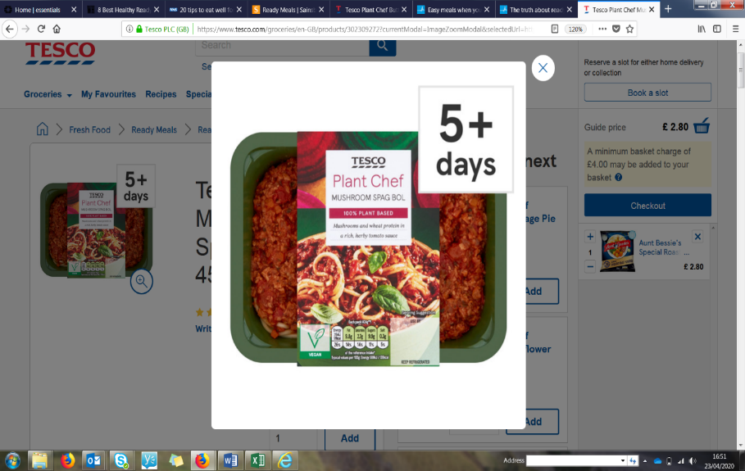For example, choose pasta in tomato sauce instead of a carbonara

**3- Go for green!**

* Check the front of pack for the traffic light label and choose the products that have the most green for fat, sugar and salt.
* Green shows they contain a low amount for these nutrient.

[Grab your reader’s attention with a great quote from the document or use this space to emphasize a key point. To place this text box anywhere on the page, just drag it.]

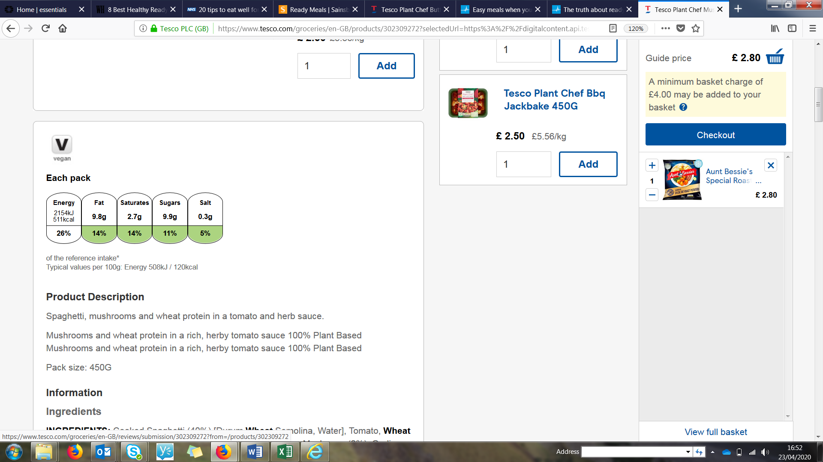

* This Mushroom Spag Bol is green for fat, saturate fats, sugar and salt so you can quickly tell it’s a healthier choice.
* It’s best to pick mostly meals that are mostly or all green. Avoid those that have a lot of red.

**4- Hold the salt!**

* Focus on picking meals with low salt – ready meals are often quite high in salt
* This is especially important for children as their bodies aren’t able to process as much salt as adults.

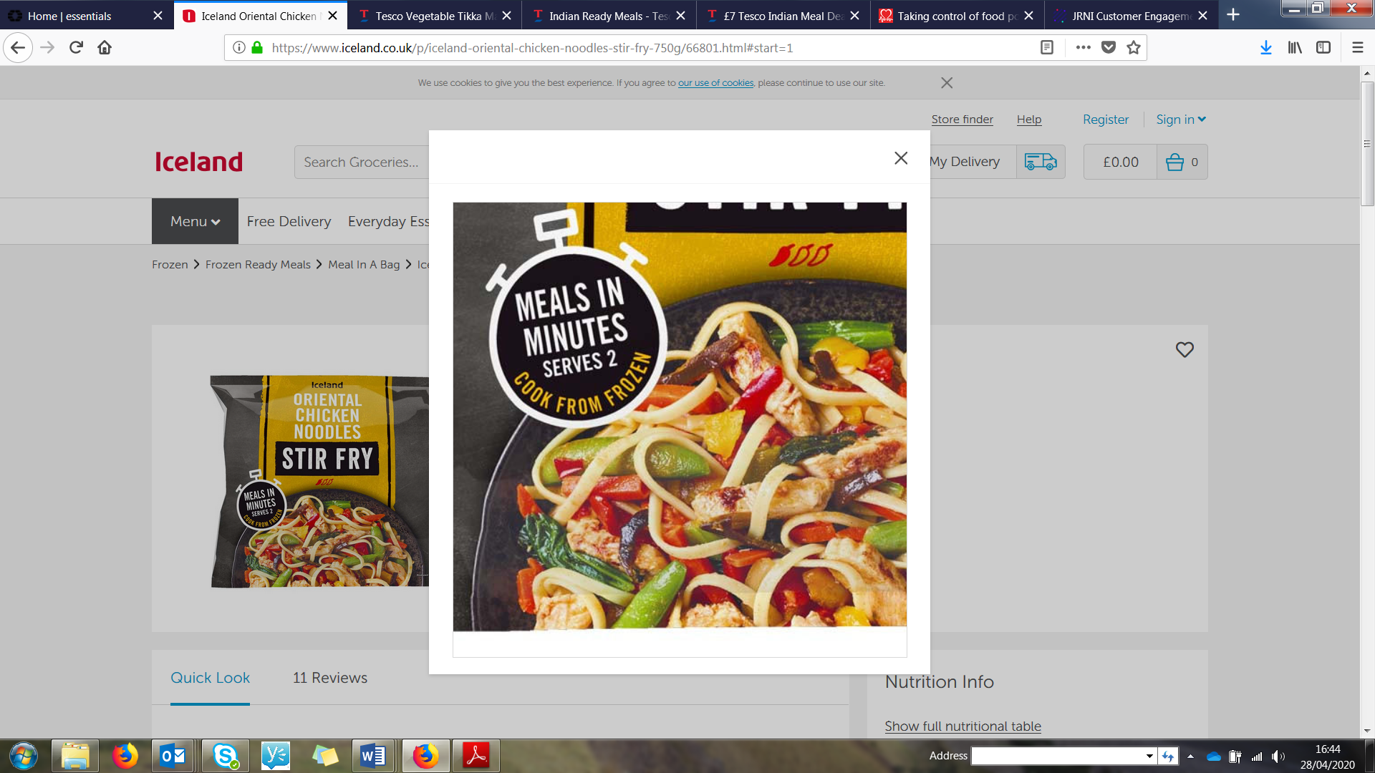

**5 – Watch portion sizes**

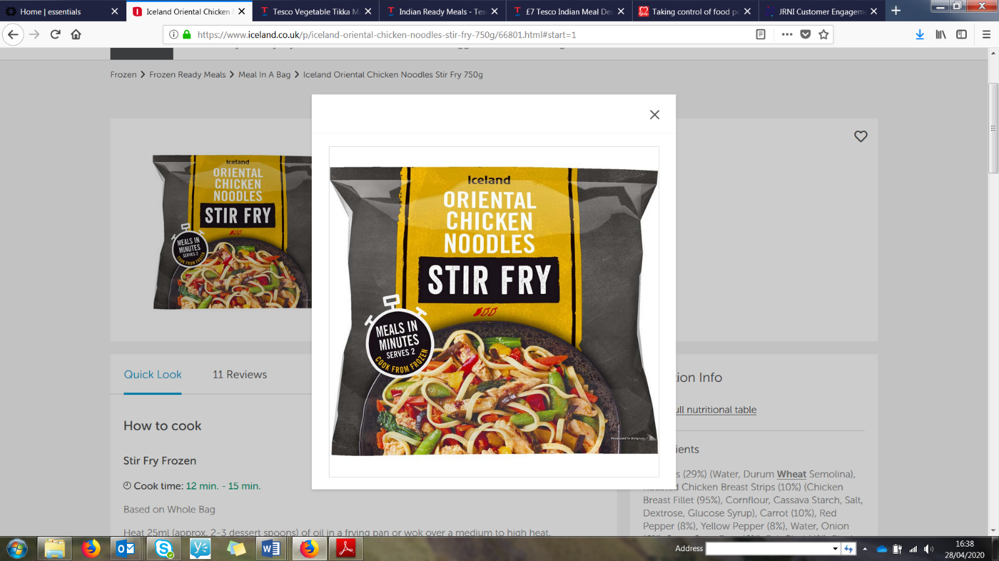

* Always read the packet to see how many people the meal is meant for.
* This oriental chicken noodle stir fry bag says it serves 2 adults but remember that children need smaller portions.
* You could also try adding in a few more noodles or veg to this meal to make serve even more people.